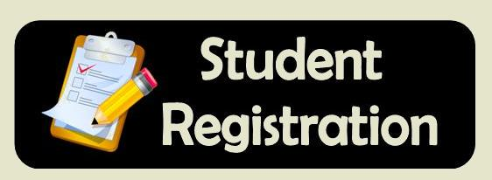
Lasara ISD Pre-K and New to District Registration
Who: Resident and Transfer Students
When: Friday, May 5, 2017
Where: Lasara ISD District Library
Time: 8:00 a.m. – 12:00 p.m. & 1:00 p.m. – 4:00 p.m.

For more information call Silvia Vasquez at 956-642-5466

